Ecological Importance of Smooth Brome in Managing Wheat Stem Sawfly (Hymenoptera: Cephidae) via Its Associated Braconid Parasitoids

May 14, 2024

This document can be downloaded as either a .docx or .pdf document. Please be aware that conversion may cause the formatting to be altered.

## Abstract

## Introduction

Ecologists and farmers frequently hold divergent views regarding the importance of natural habitats within agricultural landscapes, a distinction often overlooked in ecological and conservation discourse (**Tscharntke2016?**). While ecologists recognize the role of natural habitats in supporting biodiversity and providing potential ecosystem services like biological pest control, many farmers perceive these habitat remnants as occupying valuable cropland or even as sources of pests. As such, documenting how pest and natural enemy populations interact with agricultural landscapes alongside natural habitat buffers is important in determining the degree of the services or disservices provided.

Numerous polyphagous insect herbivores and their natural enemies rely on a variety of resources found across diverse habitat types within their environment. Depending upon the quality of the resource, different habitat types can serve as sources for increased pest or natural enemy populations. Similarly, habitat types can serve as sinks for decreased populations (**Kennedy2000?**). Altering the presence of these resources can have impacts on pest or natural enemy populations and can alter the ecology between the examined species. For example, diversifying the edge cropping of organic Kale (*Brassica oleracea*) using fava beans, fennel, and marigolds results in a diversity in beneficial arthropod communities that help reduce phytophagous herbivory (**DeMorias2023?**). Understanding the ways in which landscape habitat diversity impacts the ecological relationship between pest and enemy is crucial for effectively managing pest species in large scale cropping systems.

The wheat stem sawfly (WSS), Hymenoptera *Cephus cinctus* Norton, is a grass-mining sawfly native to North America (Lesieur et al. 2016). Originally adept at utilizing wild grass hosts, the species became a major pest to cultivated cereals as the practice became more prevalent following European settlement, becoming a notable pest of winter wheat in 1990 (**Criddle1993?**). Adult female WSS use their saw-like ovipositor to lay their eggs in the lumen of stems, where the eggs hatch, leading to larval feeding of parenchyma tissue (**Holmes1954?**). Economic damage manifests in the form of both kernel weight reduction caused by tissue damage (Beres et al. 2011) and stem toppling due to late-season larval girdling (Holmes and Peterson 1960).

Several parsitoid species attack *C. cinctus* within wild grass hosts (Davis, Benton, and Somsen 1955; Morrill, Kushnak, and Gabor 1998), however, two species, *Bracon cephis* (Gahan) and *Bracon lissogaster* Muesebeck (Hymenoptera: Braconidae), have been observed targeting WSS within cultivated cereals (Nelson and Farstad 1953; **Morrill?**). These two host-specific ectoparasitoids are native to North America. Both parasitoids are bivoltine, with the first generation present in Montana from late June to late July, while the second generation is active in August and September (Somsen and Luginbill 1956). Adult female *B. cephi* and *B. lissogaster* paralyze *C. cinctus* larvae within the host stem, paralyze the host larvae, and depositing 1 (*B. cephi*) to three (*B. lissogaster*) eggs. *B. cephi* and *B. lissogaster* have been shown to provide biological control via irreplaceable mortality of *C. cinctus* populations (Buteler et al. 2015) and can significantly reduce *C. cinctus* damage and impact on crop yields (Buteler, Weaver, and Miller 2008; Rand, Richmond, and Dougherty 2020). While *C. cinctus* has a wide range of viable host plants, including native and non-native grasses and cultivated row-crops such as wheat (*Triticum aestivum L.*) and barley (*Hordeum vulgare*)(Wallace and McNeal 1966; Cockrell et al. 2017), infestation levels can vary widely across hosts. Previous research has shown preference for host plants with larger stem diameter (Ainslie 1920; Bhandari 2020).

Smooth brome (*Bromus inermis* Lyess) is a Eurasian cool-season rhizomatous grass introduced to the United States in 1884 (Salesman and Jessica 2011).*B. inermis* was originally thought of as potentially useful as a trap crop in order to combat the growing WSS problem with cultural control practices (Farstad and Jacobson 1945). Due to its low agricultural value, and propensity to form monocultures and out compete many native grasses, *B. inermis* is categorized as invasive (Carlson and Newell 1985; Willson and Stubbendieck 2000; Dillemuth, Rietschier, and Cronin 2008). However, *B. inermis* still holds immense ecological value in its late senescence and WSS antibiosis properties (Otfinowski, Kenkel, and Catling 2006; **Rand2024?**).

Montana’s golden triangle, an area of central and northern Montana with intense cereal grain production, is prone to drought and burning via wildfire (**Wilson1923?**). As both *C. cinctus* and its conspecific parasitoids are relatively restricted in their annual mobility (Weaver et al. 2005), environmental extremes can have broad impacts on both local pest and natural enemy populations. As with many predator-prey interactions, the *C. cinctus* and parasitoid populations fluctuate similarly to wolves and moose on Isle Royale (**Peterson1999?**), with wolf populations spiking following moose populations, leading to a crash in moose, and as such, a crash in wolf.

We examined historical weather data from our field sites in central and northern Montana. We used this data to understand how changes in global climate trends may be impacting *B. cephis* and *B. inermis* populations. In addition we analyzed normalized difference vegetative index (NDVI) at our field sites to understand how *B. inermis* senescence patterns compare to adjacent cultivated wheat.

In this study, we explored the ecological patterns between Montana populations of *C. cinctus* and its braconid parsitoids in relation to *B. inermis* host sites. Our goal, was 1) to understand the degree to which *C. cinctus* infested *B. inermis* stems in relation to neighboring cereal crops, and 2) the way in which braconid parasitoids utilized WSS hosts within *B. inermis* stems. To do so, we conducted two separate studies. In our first study, we conducted controlled *C. cinctus* infestation of *B. inermis* to understand the relative infestation and cutting rate of *C. cinctus* within the *B. inermis* stems. The second study examined rates of cutting and parasitism at field sites in central and northern Montana.

Using these studies, we addressed three questions, 1) what is the total cutting, and thus source rate, of *C. cinctus* from *B. inermis*, 2) can *C. cinctus* larvae within *B. inermis* serve as second generation hosts for *B. cephi* and *B. lissogaster*, and 3) how do *C. cinctus* and parasitoid populations in *B. inermis* compare with those in adjacent cultivated wheat fields.

## Materials and Methods

### Weather data and NDVI analysis

*Weather data.* We assessed the long and medium term temperature and precipitation trends of our field sites using weather data from the National Oceanic and Atmospheric Administration (NOAA, Silver Spring, MA, USA). Data for each field site was averaged from three of the closest weather stations to that location. Data was plotted using R Studio (R Studio version 2024.04.0+735, R 2024) package ‘ggplot’ (version 3.4.4) (Wickham 2016). Data was then fit using a linear model using the ‘lm’ command using average yearly precipitation (inches) as the response variable and year as the predictor.

*NDVI analysis.* We compared the relative greening throughout the growing season between wheat fields and adjacent *B. inermis* using the normalized difference vegetation index (NDVI). NDVI is typically used to assess vegetation health and density, and is calculated from the visible and near-infared light reflected by vegetation (Pettorelli et al. 2005). Data was downloaded using Google Earth Engine (Google Inc. 2023, Mountain View, CA, USA).

### Controlled *C. cinctus* infestation of *B. inermis*

*Insects and Cages.* Assessment of *C. cinctus* infestation and mortality within *B. inermis* were assessed using a 34 x 60 ft plot at the Arthur H. Post Agronomy Farm (43°38’19.39”N, 116°14’28.86”W), an extension research station of Montana State University in Bozeman, MT. The cage structure was built using 1-inch PVC piping with the netting made using 530 $μ$ Amber Lumite Screen (BioQuip $​^{®}$ Products, LLC). Twelve cages were built to dimensions of 6ft x 3ft x 3ft (L x W x H) with cage locations selected randomly based on the space available within the plot and arranged in sets of three.

Wheat stem stubble was collected in Three Forks, MT, USA (43°38’19.39”N, 116°14’28.86”W) from fields that experienced high levels of *C. cinctus* infestation and cutting the year prior. Cut stubble, which contained *C. cinctus* larvae in diapause, were kept refrigerated between -2°C and 3°C for >100 days as required to complete obligatory larval diapause. As needed, stubs were removed from refrigeration and kept at 22-27°C for 4-5 weeks inside of 100 oz GladWare® storage containers (Glad®, Oakland, California USA). Once *B. inermis* stems reached six inches tall, stub containers with emerging sawflies were added to cages to mimic sawfly infestation pressure. Sawfly quantity treatments were as follows: high (600 stubs), low (200 stubs), and control (0 stubs).

*Data Collection.* In late August, *B. inermis* stems were collected from each cage. Each stem was sliced open using X-Acto® knives to collect data on infestation, dead larvae, live larvae, and parasitism at each internode.

### Montana Field Survey

*Stem collection and processing.* We conducted a field survey to assess *C. cinctus* infestation, larval mortality, and *B. cephi* and *B. lissogaster* prevalence within *B. inermis* and adjacent wheat fields. Sites were chosen across 2 counties in north-central Montana, United States. (Chouteau, Judith Basin), which consistently experience high *C. cinctus* pressure. Samples were collected from wheat fields and adjacent *B. inermis* in early July and late August in 2021, 2022, and 2023 from sites in Big Sandy, Moccasin, and Amsterdam, MT, USA. Sampling sites were set up as 100 $m^{2}$ polygons along the edge of adjoining wheat fields. Four collection squares of 1ft x 1ft were randomly selected within each polygon during both collection events each year. All stems within each 1 x 1 ft square were collected using a shovel to remove both stem and root material. Wheat stems were collected at distances of 5 and 20 meters from the edge of the field. Samples were collected in 4 rows at 10 meters apart. 2 samples were collected in each row at distances of 5 and 20 meters. 1 ft samples were collected at each point.

Wheat and *B. inermis* stems were then returned to Montana State University, Bozeman, Montana and stored in a 10°C cold wet storage until dissection. Stems were dissected lengthwise with a fine-bladed scalpel to determine presence or absence of *C. cinctus* larvae infestation, live eggs, dead eggs, dead larvae, live larvae, parasitism, and cutting. Sawfly larvae were identified based on descriptions in Criddle (1915) and Wallace and McNeal (1996).

*Statistical Analysis.* We used generalized linear mixed models with binomial errors (logit link) fit using bound optimization by quadratic approximation, with a maximum of 200,000 iterations, were run in the *lme4* package in R (Douglas Bates, Bolker, and Walker 2015) to examine the effects of location and year (fixed effects) on each of the three response variables: proportion of stems infested, proportion of stems cut, and proportion os stems parasitized by *Bracon* spp. ’

To better understand the density of *Bracon* spp. within the wheat and *B. inermis* sampling sites, we converted our units to the ratio of parasitoids to stem per unit area. Densities of stems are different when considering *B. inermis* and cultivated wheat or barley. Using this conversion, we attempted to better understand how the density of parasitoids (and WSS) is changed by looking at each kind of plant.

## Results

### Historical Weather Analysis & NDVI

We observed a significant linear relationship (*r = 0.1, P = 0.033, estimate = -0.058*) between average precipitation and year for both Big Sandy and Moccasin, Montana. This means that for each one year increase, we are seeing a decrease in 0.05 inches of precipitation. (Fig. 1). Additionally, we observed a significant positive linear relationship (*r = 0.245, P < 0.05, estimate = 0.028*) between year and average yearly temperature for Moccasin and Big Sandy, MT. This means that each year, the average daily temperature has increased by 0.03°C. (Fig. 2).

We observed a notable difference in NDVI when comparing adjacent *B. inermis* and spring wheat. We saw a significant difference in the July NDVI (*0.846, P < 0.05*). The *B. inermis* NDVI remained relatively linear in it’s downslope (BROME SLOPE POST JULY) compared to the wheat field (WHEAT FIELD POST JULY). (Fig. 3)

Need to add map showing where NDVI measurments came from

### Controlled *C. cinctus* Infestation of *B. inermis*

*C. cinctus* showed high infestation of *B. inermis* in the controlled test conditions. Averaged across both years, we observed 66.5% of stems infested for high treatments and 47.3% of stems for low treatments. We found strong evidence suggesting that there was a significant difference between infestation at high and low treatment levels when holding year constant (*r = 0.83, P < 0.05*, Fig. 3).

Cutting was observed at 5.7% for the high treatments and 3.9% for the low, showing strong evidence for a difference in cutting between high and low treatment groups (*r = 0.592, P < 0.05*).

*C. cinctus* infested stems often contained larvae burrowing through multiple nodes. In 2022, 64.3% of stems were observed to have at least 4 nodes burrowed through. In 2023, 61.7% of stems had at least 4 nodes infested Fig. 5

### Montana Field Sites

We quantified *C. cinctus* and *Bracon* spp. parasitoid presence in 6,148 wheat and grass stems across 10 research sites in 2022 and 2023. Infestation by *C. cinctus* within *B. inermis* varied between collection sites, with the greatest infestation taking place within our three Big Sandy, MT sampling sites (2023: 65.4%, 2022: 63.1%), while the lowest infestation observed was in Moccasin, MT (2023: 40.8%, 2022: 60.7%). Across all sites in Big Sandy and Moccasin, we observed an average infestation of 57.5% within *B. inermis* and 47.6% within the adjacent wheat. Cutting by *C. cintus* was observed at an average rate of 5.59% (se = 0.0164) in *B. inermis* and 47.1% (se = 0.0386) in the adjacent cultivated wheat (fig. 7.

To generate a relative estimate of the number of available *C. cinctus* host larvae within *B. inermis* late in the growing season, we calculated the number of stems that contained at least four or more nodes of infestation. In Big Sandy, 76.2% of collected stems in the fall exhibited at least 4 nodes of infestation. In Moccasin, the corresponding figure was 66.5%.

# A tibble: 4 × 5  
# Groups: collection, year, region [4]  
 collection year region brome wheat  
 <chr> <chr> <chr> <dbl> <dbl>  
1 fall 2022 big sandy 5 0.310  
2 fall 2022 moccasin 1.36 0.105  
3 fall 2023 big sandy 2.33 0.591  
4 fall 2023 moccasin 1.27 0.115

[1] 155

[1] 1

[1] 16.12903

We utilized the ratio of parasitized stems to cut stems to better understand the true impact of our *B. inermis* sink/source ecology. The largest ratio observed was in Big Sandy, MT in the fall of 2022, where we observed a ratio of 16 parasitoids to 1 cut stem. This means that for every 1 square meter of *B. inermis*, we would observe 16 stems that produced a parasitoid for every 1 stem that produced an adult *C. cinctus*. All three other sample selections also showed positive ratios of parasitoids to cut stems fig. 8.

I want to drive home that stems with 3 + nodes infested likely had larave that were alive late into the summer. Compare the number of nodes infested in the summer to stems that have 3+ infested in the fall.

## Discussion

Assessing the comparative abundance of *C. cinctus* and its associated parasitiods within *B. inermis* and adjacent cultivated cereal hosts is an important initial step in evaluating whether semi-natural environments within road-side or coulee areas could potentially serve as origins for both pests and beneficial natural adversaries infiltrating agricultural crops.

## Figures

### Figure 1

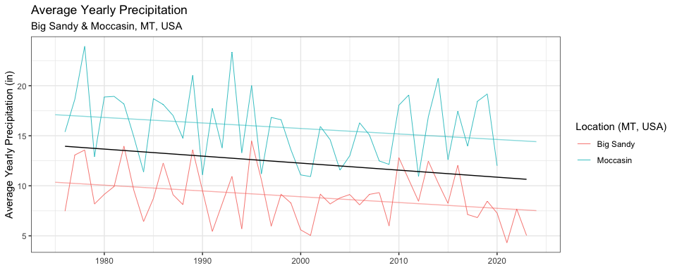

Figure 1: Average yearly precipitation (in) for Big Sandy and Moccasin, Montana. Black trend line signifies averaged negative trend between both locations. Data gathered from NOAA and MSU-ARS. A significant linear relationship (r = 0.1, P = 0.033, estimate = -0.058) was observed between year and average yearly precipitation.

### Figure 2

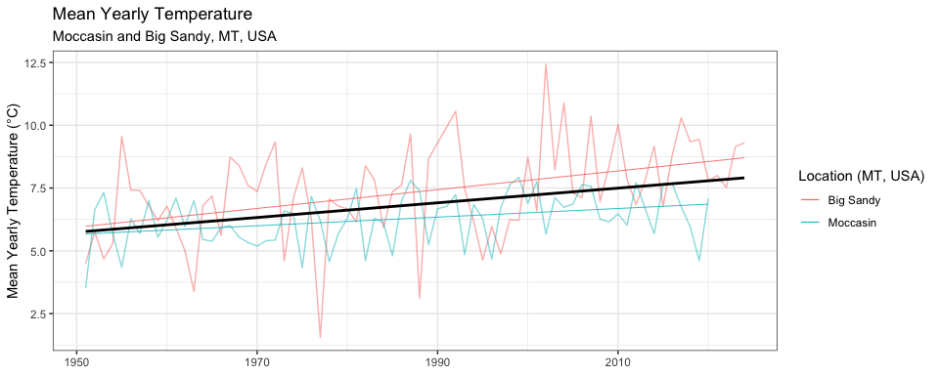

Figure 2: Average yearly temperature (°C) in Moccasin and Big Sandy, MT. Positive trendline slop suggests increasing average temperatures of the past 100 years. A significant linear relationship (*r =0.2447, P < 0.05, estimate = 0.028*) was observed between year and average yearly temperature.

### Figure 3

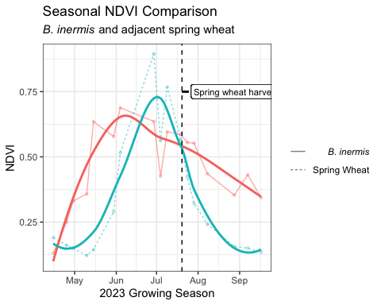

Figure 3: Normalized difference vegetation index (NDVI) of *B. inermis* and adjacent spring wheat field from April 2023 to October 2023. Post harvest linear model indicates a significant difference (P values and stuff) when comparing the *B. inermis* post-harvest slope and the spring wheat post-harvest slope.

### Figure 4

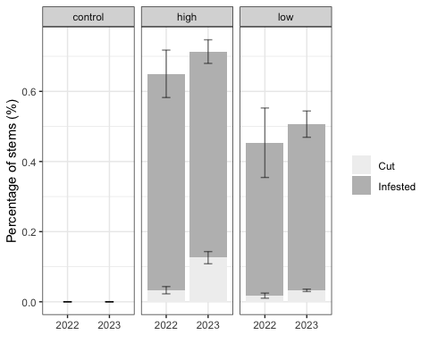

Figure 4: Comparison of year and treatment group for controlled infestation of *B. inermis*. We observed a significant difference in cutting between high and low treatment groups (*r = 0.592, P < 0.05*).

### Figure 5

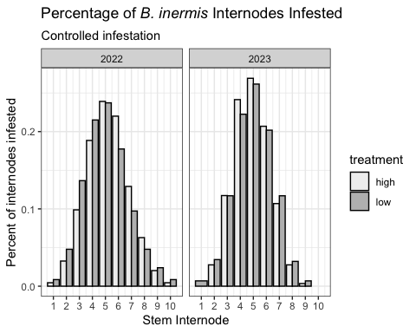

Figure 6: Ineternodes infested by *B. cephi* within controlled infestation plots in Bozeman, MT, USA. We found that 61.2% of stems exhibited infestation in at least 5 nodes

### Figure 6

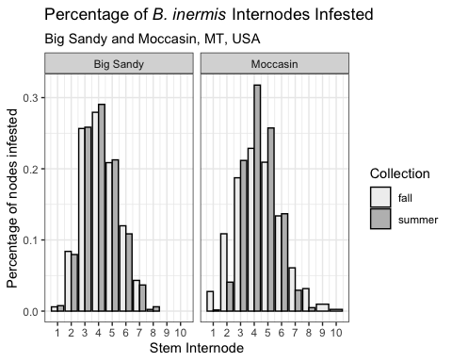

Figure 6: Internodes infested by *B. cephi* within collected *B. inermis* stems in Moccasin and Big Sandy, MT, USA.

### Figure 7

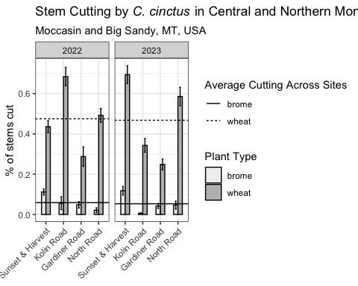

Figure 7: Stem cutting by *C. cinctus*. We compared WSS cutting in *B. inermis* and adjacent wheat fields in Big Sandy and Moccasin, MT, USA. The horizontal lines correspond to yearly mean cutting for each plant type across all sampling sites.

### Figure 8

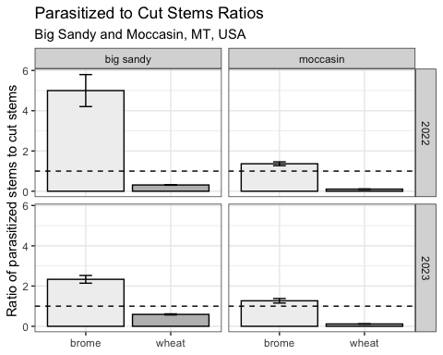

Ratios of parasitized to cut stems in *B. inermis* and adjacent cultivated wheat. Dotted line represents where a 1:1 cut:parasitized ratio lies.

## Citations

Ainslie, C. N. 1920. “The Western Grass-Stem Sawfly.” *United States Department of Agriculture*.

Beres, B. L., L. M. Dosdall, D. K. Weaver, H. A. Cárcamo, and D. M. Spaner. 2011. “Biology and Integrated Management of Wheat Stem Sawfly and the Need for Continuing Research.” *Canadian Entomologist* 143: 105–25. <https://doi.org/10.4039/n10-056>.

Bhandari, Rekha. 2020. “[Assessment of Host Selection Behaviors and Oviposition Preferences of Cephus Cinctus Norton (Hymenoptera: Cephidae) Using Wheat and Smooth Brome](https://www.ncbi.nlm.nih.gov/pubmed/25246403).”

Buteler, Micaela, Robert K. D. Peterson, Megan L. Hofland, and David K. Weaver. 2015. “A Multiple Decrement Life Table Reveals That Host Plant Resistance and Parasitism Are Major Causes of Mortality for the Wheat Stem Sawfly.” *Environmental Entomology* 44: 1571–80. <https://doi.org/10.1093/ee/nvv128>.

Buteler, Micaela, David K. Weaver, and Perry R. Miller. 2008. “Wheat Stem Sawfly-Infested Plants Benefit from Parasitism of the Herbivorous Larvae.” *Agricultural and Forest Entomology* 10 (November): 347–54. <https://doi.org/10.1111/j.1461-9563.2008.00396.x>.

Carlson, I T, and L C Newell. 1985. “Smooth Bromegrass.” In *Forages: The Science of Grassland Agriculture*, 198–206. Iowa State University. <https://www.cabdirect.org/cabdirect/abstract/19850777665>.

Cockrell, Darren M., Robert J. Griffin-Nolan, Tatyana A. Rand, Nuha Altilmisani, Paul J. Ode, and Frank Peairs. 2017. “Host Plants of the Wheat Stem Sawfly (Hymenoptera: Cephidae).” *Environmental Entomology*. Entomological Society of America. <https://doi.org/10.1093/ee/nvx104>.

Davis, E. G., Curtis Benton, and H. W. Somsen. 1955. “Natural Enemies of the Wheat Stem Sawfly in North Dakota and Montana.” *North Dakota Agricultural Experimental Bimonthly Bulletin* 18: 63–65.

Dillemuth, Forrest P., Erick A. Rietschier, and James T. Cronin. 2008. “Patch Dynamics of a Native Grass in Relation to the Spread of Invasive Smooth Brome (Bromus Inermis).” *Biological Invasions 2008 11:6* 11 (September): 1381–91. <https://doi.org/10.1007/S10530-008-9346-7>.

Douglas Bates, MM, Ben Bolker, and Steve Walker. 2015. “Fitting Linear Mixed-Effects Models Using Lme4.” *Journal of Statistical Software* 67 (1): 1–48.

Farstad, C. W., and L. Jacobson. 1945. “Manual for Sawfly Control Workers in Alberta.” Canadian Department of Agriculture - Division of Entomology.

Holmes, N. D., and L. K. Peterson. 1960. “THE INFLUENCE OF THE HOST ON OVIPOSITION BY THE WHEAT STEM SAWFLY, CEPHUS CINCTUS NORT. (HYMENOPTERA: CEPHIDAE).” *Canadian Journal of Plant Science* 40 (January): 29–46. <https://doi.org/10.4141/cjps60-004>.

Lesieur, Vincent, Jean François Martin, David K. Weaver, Kim A. Hoelmer, David R. Smith, Wendell L. Morrill, Nassera Kadiri, et al. 2016. “Phylogeography of the Wheat Stem Sawfly, Cephus Cinctus Norton (Hymenoptera: Cephidae): Implications for Pest Management.” *PLoS ONE* 11 (December): 168370. <https://doi.org/10.1371/journal.pone.0168370>.

Morrill, Wendell L., Gregory D. Kushnak, and James W. Gabor. 1998. “Parasitism of the Wheat Stem Sawfly (Hymenoptera: Cephidae) in Montana.” *Biological Control* 12: 159–63. <https://doi.org/10.1006/bcon.1998.0629>.

Nelson, W. A., and C. W. Farstad. 1953. “Biology of Bracon Cephi (Gahan) (Hymenoptera: Braconidae), an Important Native Parasite of the Wheat Stem Sawfly, Cephus Cinctus Nort. (Hymenoptera: Cephidae), in Western Canada.” *The Canadian Entomologist* 85: 103–7. <https://doi.org/10.4039/Ent85103-3>.

Otfinowski, R, N C Kenkel, and P M Catling. 2006. “The Biology of Canadian Weeds. 134. Bromus Inermis Leyss.” *Canadian Journal of Plant Science* 87: 183–98.

Pettorelli, Nathalie, Jon Olav Vik, Atle Mysterud, Jean Michel Gaillard, Compton J. Tucker, and Nils Chr Stenseth. 2005. “Using the Satellite-Derived NDVI to Assess Ecological Responses to Environmental Change.” *Trends in Ecology and Evolution*. <https://doi.org/10.1016/j.tree.2005.05.011>.

Rand, Tatyana A., Courtney E. Richmond, and Edward T. Dougherty. 2020. “Modeling the Combined Impacts of Host Plant Resistance and Biological Control on the Population Dynamics of a Major Pest of Wheat.” *Pest Management Science* 76 (August): 2818–28. <https://doi.org/10.1002/ps.5830>.

Salesman, Jessica Bolwahn, and Meredith Thomsen Jessica. 2011. “Smooth Brome (Bromus Inermis) in Tallgrass Prairies: A Review of Control Methods and Future Research Directions.” *Ecological Restoration* 29: 374–81. <https://doi.org/10.3368/er.29.4.374>.

Somsen, H. W., and P Luginbill. 1956. “Bracon Lissogaster Mues: A Parasite of the Wheat Stem Sawfly.” *USDA Technical Bullitin* 1153. <https://www.google.com/books/edition/Bracon_Lissogaster_Mues/37UXAAAAYAAJ?hl=en&gbpv=1&dq=Bracon+Lissogaster+Mues:+A+Parasite+of+the+Wheat+Stem+Sawfly.&pg=PA29&printsec=frontcover>.

Wallace, Lew E., and F. H. McNeal. 1966. “Stem Sawflies of Economic Importance in Grain Crops in the United States.” *U.S. Department of Agriculture Technical Bulletin No. 1350*. <https://books.google.com/books?hl=en&lr=&id=dcMXAAAAYAAJ&oi=fnd&pg=PA1&dq=Stem+sawflies+of+economic+importance+in+grain+crops+in+the+United+States&ots=e0FbKZOb6x&sig=_fPd1FCRZ_HK-Ncv2POX-EFMvOo#v=onepage&q=Stem sawflies of economic importance in grain cro>.

Weaver, David K., Christian Nansen, Justin B. Runyon, Sharlene E. Sing, and Wendell L. Morrill. 2005. “Spatial Distributions of Cephus Cinctus Norton (Hymenoptera: Cephidae) and Its Braconid Parasitoids in Montana Wheat Fields.” *Biological Control* 34 (July): 1–11. <https://doi.org/10.1016/j.biocontrol.2005.04.001>.

Wickham, Hadley. 2016. *Ggplot2: Elegant Graphics for Data Analysis*. Springer-Verlag New York. <https://ggplot2.tidyverse.org>.

Willson, Gary D., and James Stubbendieck. 2000. “A Provisional Model for Smooth Brome Management in Degraded Tallgrass Prairie.” *Ecological Restoration*. <https://doi.org/10.3368/er.18.1.34>.